Parking Aid

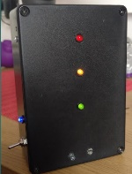

Mateo Ceballos Querol

Student number: 100448597
Word Count: 1,561

Technology Project
Year 0 – Electrical and Electronic Engineering
College of Engineering and Technology
30th April 2018

Table of Contents
1. Abstract iii
2. Introduction 3
3. The process 4
3.1 The Op Amp Comparator 4
3.2 Design the Veroboard™ circuit 4
3.3 Assembly 5
3.3.1 Placing components on the Veroboard™ 5
3.3.2 Building the box 5
3.4 Debugging 5
4. Conclusions 7
5. Recommendations 7
6. Bibliography 7
7. Appendices 8
7.1 Appendix A - Schematics 8
7.2 Appendix B - Fritzing™ designs 11
7.3 Appendix C - Veroboard™ Assembly 15
7.4 Appendix D - The box 18

Abstract

The purpose of this technical report is to go into detail about the thinking process of how I came about to make the parking aid Veroboard design, how I implemented the design into a box, as well as all the issues that I encountered along the way. Apart from making a working circuit, time management was important. I was given 12 weeks to do the assignment, I had created a Gantt chart; this allowed me to see how long I would be spending on each task. After 11 weeks I finally got the circuit working and in a box. A range of equipment was used for this project such as Fritzing™, a software used to make the designs.

Introduction

Without going into too much detail about the precise operation of a 555 timer, it consists of 3 5k Ω resistors; which is where it gets its name from. Inside it is a R-S flip flop, which is very complicated to explain but essentially it has an output (pin 3) and a complementary of the output (pin 7). (555 timer teardown, 2018). The 555 is set to astable mode and generates a square wave.

The process

3.1 The Op Amp Comparator

The LM324AJ is an Operational Amplifier Comparator (Op Amp Comparator, for short (see Figure 2 in Appendix A. It has two inputs which are compared, an inverting input (negative pin) and a (reference voltage) positive pin. Looking at the schematic, (Figure 3 in Appendix A) the negative voltage pins 6, 9 and 13 are connected to the output of the photodiode, while pins 5, 10 and 12 are connected to the positive voltage (9V) or what is known as the reference voltage. The way the op amp works is that when the inverting input exceeds the positive voltage, the potential difference across the output pins 7, 8 and 14 and their respective LEDs will be 0 hence turning on the LEDs. (Dummies, 2017).

3.2 Design the Veroboard™ circuit

The schematic (see Figure 1 in Appendix A) is shown to be in two separate parts and was it first assumed that it how is should look in the final product; on two separate Vero-boards™. That, however, was not the case in the end, as both halves were connected to both the 9V battery and the ground
The 555 ‘half’ of the circuit was the logical place to start as that had the least components, the best way to design it was to place the IC and build around it; as can be seen in Figure 1 of Appendix B. The components of this design are very spread out. That can be corrected by moving it up and right; only occupying about a third of the Veroboard’s total size.
Figure 2 in Appendix B shows the receiver half of the circuit. There is a lot of empty space in between the LM324AJ and the grounding track. Since the components surrounding the 555 timer takes up about a third of the board’s length, this left around two thirds of the board’s length for the LM324AJ and the components surrounding it; this ended up in a very optimal use of the board’s space with only a few empty tracks (that was due to the board dimensions being greater than needed).
After combining both halves. There was still some empty space which could be compressed even further (see Figure 3 in Appendix B). For this stage, the 555 timer and its surrounding components were shifted up two tracks so that all the positive wires would be linked to the first track. However, the ground track, was left in the middle of the board; for simplicity. Also, this design was still missing some components: those 4 voltage-drop resistors connected in series to ground from Figure 3 in Appendix A (4th resistor is 1kΩ and connected to ground after the 1kΩ resistor). In terms of the coloured LEDs, they are very far apart and in reversed order. Although, the IR LED is connected to pin 3 of the 555 timer and positive track, and the photodiode which is connected to pin 2 and ground are placed right next to each other on the top right corner of the box; this made the box making process and faster.
The final design, (see Figure 4 in Appendix B) can be seen with all the components correctly placed. The coloured LEDs have been moved to the opposite side of the board, and they are in a straight line. However, it later turned out it was an issue with the schematic and the green and red LEDs were switched.

3.3 Assembly

3.3.1 Placing components on the Veroboard™

The most challenging part of placing the components on the Veroboard™, was understanding how to make connections in parallel; it looked easier than it was. To make it easier on the soldering, the components were placed in a certain order so that the board would balance whenever it was flipped over to solder. The specific order was from small to big, in terms of height: the wires were soldered in first (see Figure 1 in Appendix C) then the resistors, followed by the two diodes, then the chip holders for the 555 and LM324AJ and finally the capacitors and the wires for the 5 LEDs.

3.3.2 Building the box

Making the box was perhaps the shortest task throughout the duration of this project. A T shape was drawn with masking tape on the lid of the box, measured with a ruler to make sure that the holes for the LEDs would turn out to be straight. As mentioned, the LEDs were at the opposite side of the box, in order from green to red which made it very easy to place the holes, the holes for the coloured LEDs were placed at around the middle of the lid, about 3cm from each other. The IR LED and the photodiode were placed at the bottom, it was very crucial that they were placed at two cm away from each other on the opposite end of the lid, this is because it was measured that there needs to be a minimal horizontal distance for it to detect an object. (see Figure 1 in Appendix D for the box) The toggle switch and a blue power indicator LED were placed on the bottom left hand side of the box; to prevent the switch from turning sideways a nut was placed inside the box and one outside.

3.4 Debugging

The most stressful and frustrating aspect of this project, many different types of errors occurred ranging from blown components to shorts. Once the final design was made and the components were placed accordingly, the circuit did not work; as expected. After a few seconds of the battery being connected to the 9V battery adapter, it started to heat up really fast. Thanks to the continuity test on the multi-meter, it was relatively easy to find the faults. Starting from pin 1 of the 555 and going all the way to pin 14 of the LM324AJ, the connections were marked with a tick on a printed version of the schematic, and those that did not connect but were supposed to be connected, were marked with a cross. Most of the problems were shorts, meaning that positive and negative wires were connected directly; the cause of the battery heating up. That however, was easily fixed with track breaks and after about 14 track breaks, the battery did not overheat. A huge mistake which could have been easily avoided was that two of the capacitors were of rectangular shape and took a minimum of 3 spaces on the board; several wires had to be made either one space shorter or one space longer to adapt to that type of capacitor.

The 555 timer should display a square wave when pin 3 is probed using the oscilloscope. A screenshot taken from the oscilloscope (see Figure 2 in Appendix C) shows that the measured frequency was around 100Hz. The following equation can help us to determine the theoretical period of one wave coming out of the 555 timer, which is given by:

$$T=0.693\left(R_{1}+2R_{2}\right)C$$
R₁ is 10kΩ, R₂ is 1kΩ and C is 1μF. Substituting all the values in it comes out as:
$$T=0.693\left(10000+2(1000)\right)0.000001$$
$$T=0.008316 s$$
This can then give us the ideal frequency by doing the reciprocal.
$$f=\frac{1}{T}$$
$$f=\frac{1}{0.008316}$$
$f=120.25$Hz
The difference of 20 Hz is due to the tolerance values of the resistors and of the polarized capacitor, of up to ±20% (Capacitor Guide, 2018).

The Infrared LED which is connected to pin 3, turning on and off at about 100Hz. The only way to see the light was through a phone camera, and it looks something like what can be seen in Figure 3 in Appendix C.

Conclusion

To conclude this lengthy technical report, it is safe to say that the circuit is in its box and works the way it should do. Looking at the frequency from the square wave generated by the 555 timer, there will always be uncertainties in the values of components such as resistors and capacitors which will be out of control. However, the IR LED and photodiode could be changed for it to detect objects at a greater distance.

Recommendations

For a better way to determine distance, LEDs could’ve been replaced with a signal generator of sorts. A pulsating beep from a speaker, and the closer an object gets to the photodiode, the faster it would beep, until the frequency of the noise is so high that it’s one continuous sound.

Bibliography

555 timer teardown: inside the world's most popular IC. 2018. 555 timer teardown: inside the world's most popular IC. [ONLINE] Available at: http://www.righto.com/2016/02/555-timer-teardown-inside-worlds-most.html.
Wilson, D 2018, Technology project Circuit Designs. Soldering. 555 Timer Operation. Health and safety, lecture, Technology project 3EJ504, University of Derby, 12/02/2018.
alldatasheet.net. 2018. LM324AJ Manufacturer, Function, Datasheet | Texas Instruments. [ONLINE] Available at: http://manufacture.alldatasheet.net/view.jsp?sField=4&Searchword=LM324AJ&list=Texas%20Instruments.
dummies. 2018. Electronics Components: How to Use an Op Amp as a Voltage Comparator - dummies. [ONLINE] Available at: http://www.dummies.com/programming/electronics/components/electronics-components-how-to-use-an-op-amp-as-a-voltage-comparator/.
Electrolytic Capacitor » Capacitor Guide. 2018. Electrolytic Capacitor » Capacitor Guide. [ONLINE] Available at: http://www.capacitorguide.com/electrolytic-capacitor

7. Appendices

7.1 Appendix A - Schematics

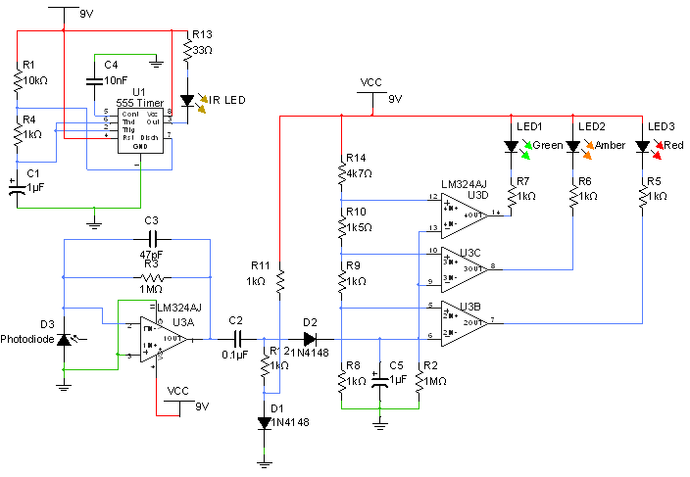
Figure 1

(Dave Wilson, 2017)

Figure 2

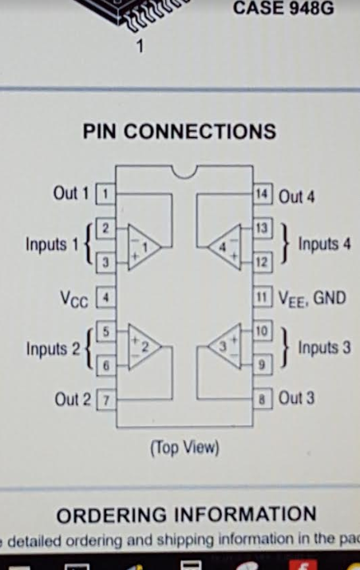

(Texas Instruments – LM324AJ, 2015)

Figure 3
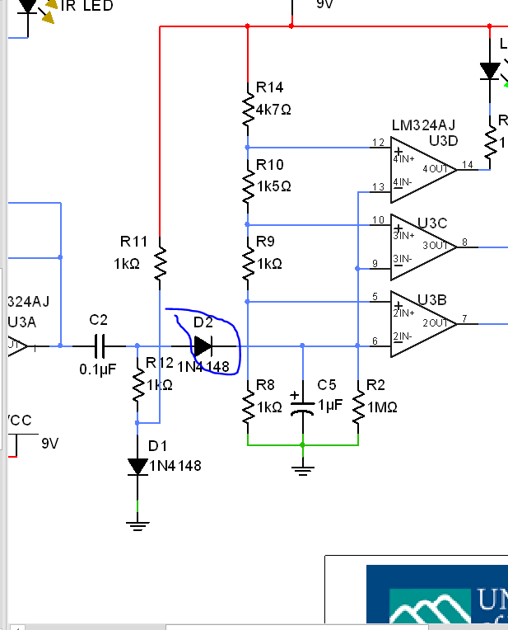

(Dave Wilson, 2017)

7.2 Appendix B - Fritzing™ Designs

Figure 1

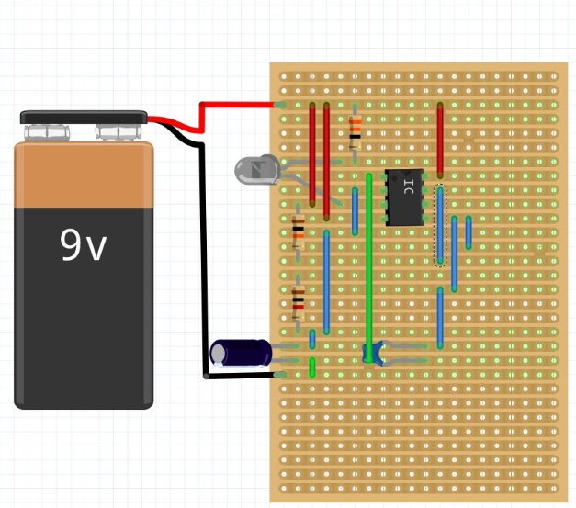

Figure 2
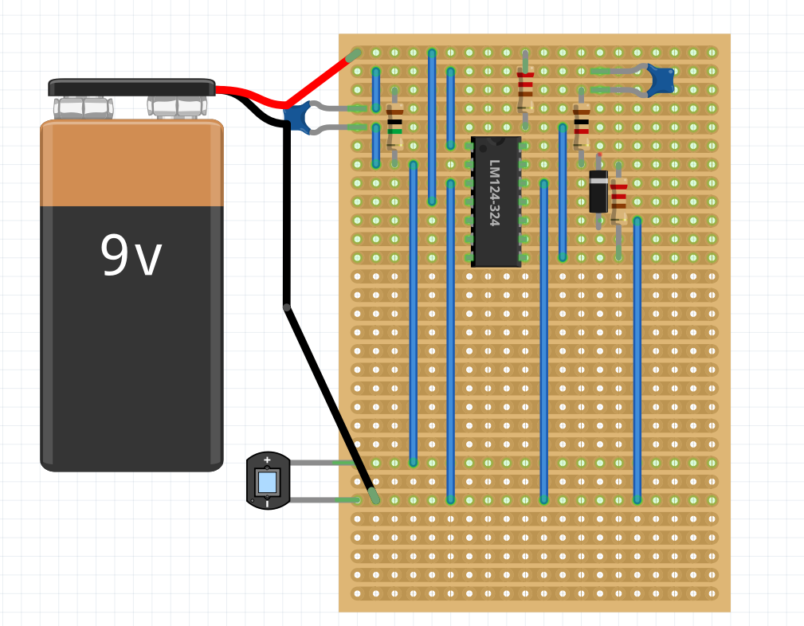

Figure 3
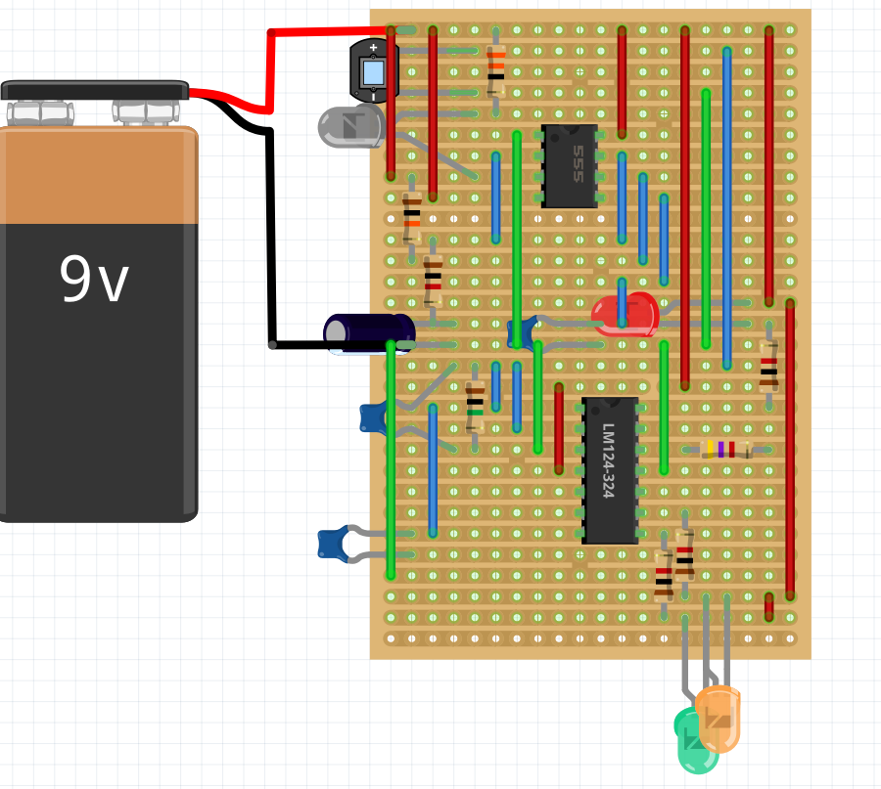

Figure 4

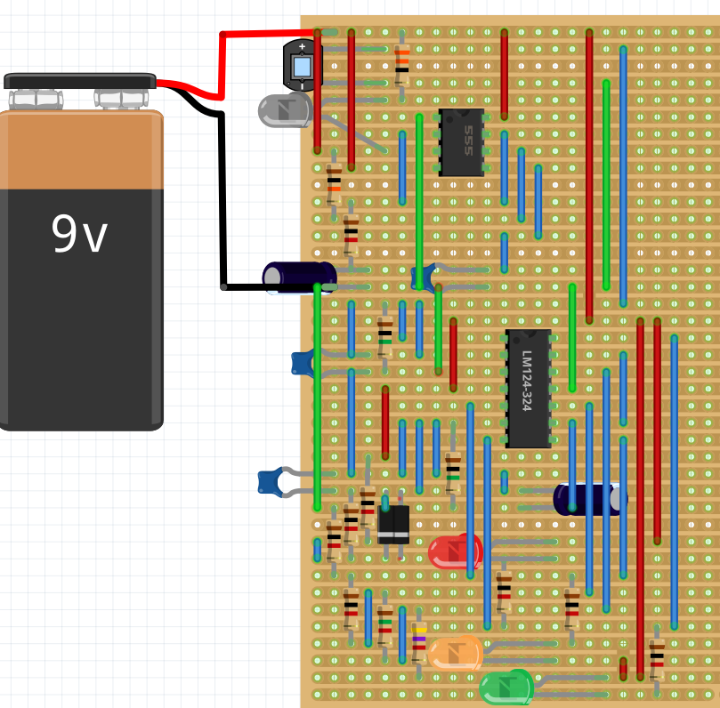

7.3 Appendix C - Veroboard™ Assembly

Figure 1
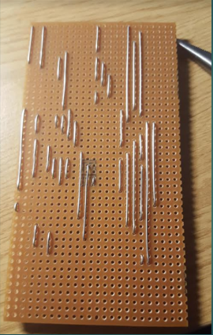

Figure 2
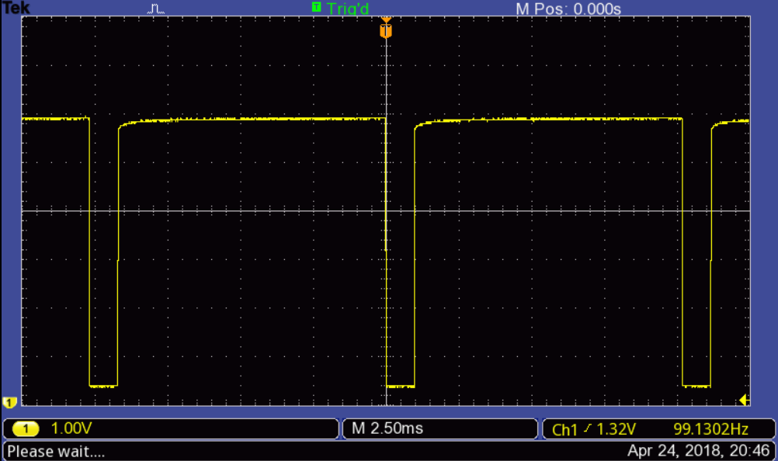

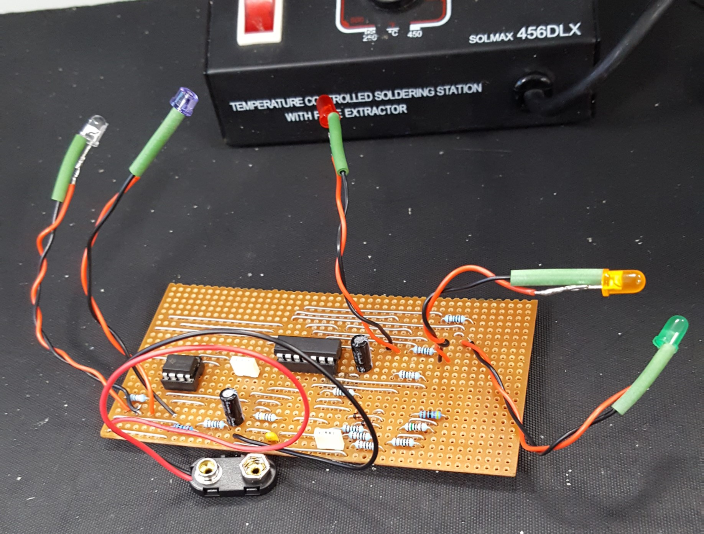
Figure 3

7.4 Appendix D - The box

Figure 1
